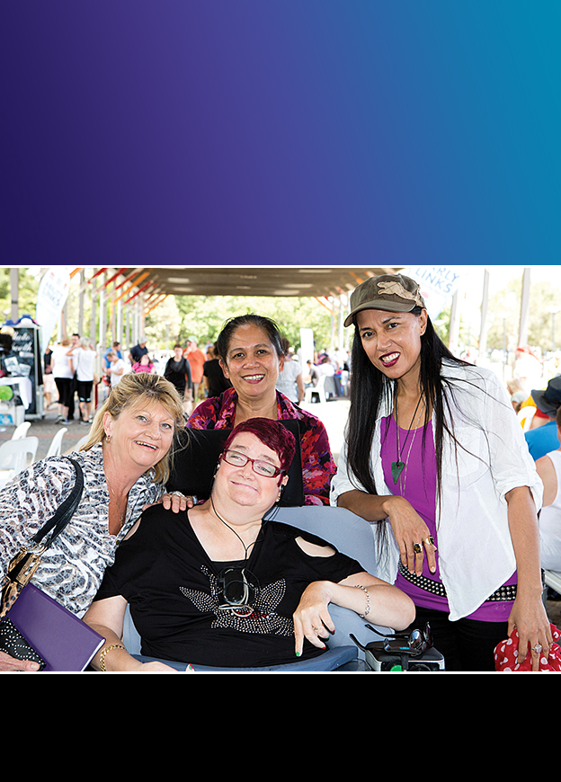
Newcastle City Council

Disability Inclusion
Action Plan
2016 – 2019

2111JAN16
www.newcastle.nsw.gov.au
Newcastle City Council acknowledges the traditional country of the Awabakal and Worimi peoples.
We recognise and respect their cultural heritage, beliefs and continuing relationship with the land, and that they are the proud survivors of more than two hundred years of dispossession.
Council reiterates its commitment to addressing disadvantages and attaining justice for Aboriginal and Torres Strait Islander peoples of this community.

CONTENTS
Published by
Newcastle City Council
PO Box 489, Newcastle NSW 2300
Phone: 4974 2000 Fax: 4974 2222
Email: mail@ncc.nsw.gov.au
Web: www.newcastle.nsw.gov.au
Enquiries
For information about the Disability Inclusion Action Plan,
contact: Community Development Facilitator
Phone: 4974 2000
March 2016 © 2016 Newcastle City Council

Statement of Commitment 4
About this Plan 5
Newcastle 2030 Community Strategic Plan 8
National and Legislative Context 10
Newcastle City Council Disability Access and Inclusion Action Plan 13
Council's Role in Working for the Community 15
Council's Community Planning and Development Roles and Responsibilities 17
Community Consultation and Emerging Key Issues in Newcastle 18
Strategies and Actions 24
Monitoring and Evaluation 32

STATEMENT OF COMMITMENT
We as prominent citizens and representatives of organisations in Newcastle affirm our commitment to:
- Advocating equal rights for all and improving our city as an accessible and inclusive place,
- Striving for an inclusive society through collaborations with community, business and government groups,
- Improving awareness of and access to Council facilities for improved community wellbeing.

ABOUT THIS PLAN
4 Newcastle City Council

Newcastle City Council's Disability Inclusion Action Plan is a four year framework outlining the key strategies and action areas to be delivered by Council in its commitment to disability access and inclusion within the Newcastle local government area. It is prepared under a hierarchy of legislation: Commonwealth and State, as well as, Newcastle's local community planning framework known as 'Newcastle 2030' the Community Strategic Plan.
The NSW Government Disability Inclusion Plan demonstrates the case for an inclusive and equitable society. It acknowledges the benefits in embracing diversity and the need to continue to strive for increased access and inclusion for individuals, families and carers.
"An inclusive society does not only benefit people with disability. There is a strong case based on research showing how inclusion benefits everyone:
As a community, we are stronger with a diverse range of viewpoints and perspectives, and as a whole we are enriched through activities that promote inclusion. Inclusion reduces disadvantage, isolation and discrimination. It has far reaching positive impacts across all aspects of life, including health, welfare, education and employment. These impacts are felt beyond the individual, with families and the broader community all being positively impacted by an inclusive society.
There are strong economic reasons for increasing the inclusiveness of our society. Analysis indicates that there are significant financial gains for both individuals and for the economy by moving people into productive and fulfilling employment.
Although the need for a more inclusive NSW is now better recognised and the benefits for individuals, families, carers and the community increasingly understood, we still have a long way to go. It is time for government, community, businesses and people with disability to work together to make an inclusive NSW a reality."
Newcastle City Council's Disability Inclusion Action plan is Council's way of defining how the organisation will make targeted and continual effort to reduce the barriers that people face when living, working and visiting the Newcastle local government area.

It documents the steps Council will take in working towards (with regard to access and inclusion) the Newcastle 2030 Community Strategic Vision:
"In 2030 Newcastle will be Smart, Liveable and Sustainable City. We will celebrate our unique city and protect our natural assets. We will build resilience in the face of the future and encourage innovation and creativity. As an inclusive community, we will embrace new residents and foster a culture of care.
We will be a leading lifestyle city with vibrant public places, connected transport networks and a distinctive built environment. And as we make our way toward 2030, we will achieve all this in a framework of open and collaborative leadership."
Newcastle is the largest regional centre in NSW and the second largest non-capital urban centre in Australia. The city offers a remarkable and diverse natural environment from coastal headlands and beaches to wetlands, mangrove forests, steep ridges and rainforest gullies.
The Newcastle local government area (LGA) has a population of 148,531 people (2011) in an area of 214 square kilometres.
Newcastle has been on a journey of significant change as it evolves from an industrial to a post-industrial city led predominantly by the knowledge (eg education, health and technology) and service based sectors. Our LGAis expected to continue its growth, with an additional
32,000 people, anticipated by 2036, as part of an additional 133,000 people in
the Hunter.
“Persons with disabilities include those who have long-term physical, mental, intellectual or sensory impairments which in interaction with various barriers may hinder their full and effective participation in society on an equal basis with others”
– United Nations Convention on the Rights of Persons with Disabilities
Diversity within our community is acknowledged. The Newcastle community reflects many different cultural groups. Acknowledging diversity and individuality in ability is an important part of committing to the principles of access and inclusion. It is recognised that peoples experience living with disability is not easily categorised and sometimes not easily seen.
Newcastle City Council's demographic profile details that 8,727 people or 5.9% of the population in the City of Newcastle in 2011, reported needing help in their
day-to-day lives due to disability.

Newcastle's disability statistics (which are based on Australian Bureau of Statistics 2011 Census data) relate directly to need for assistance due to a severe or profound disability. Whilst the statistics help in understanding the prevalence of people who need support in the community, it is acknowledged that the number does not include all people living with and caring for people with disability in the Newcastle community.
Across the state of NSW, more than 1.3 million people live with disability, of these people 420,000 have a severe or profound disability that affects their ability to communicate, get around and care for themselves.
The role of carers must also be acknowledged. Carers also play a vital role in the wider community. A carer is someone who provides ongoing unpaid support to older people, people with disabilities or people with long-term health conditions and make a significant contribution to the lives of those they care for". In NSW, the total number of carers is 857,000.
In recent years there has been significant policy changes in Australia with the introduction of the National Disability Insurance Scheme (NDIS). Since 2013, Newcastle has been a trial site for the role out of the NDIS in NSW. The fundamental principle of the changes is recognition that people with disability have the right to full and effective participation in an inclusive society. As a result of the implementation of the NDIS there has been a great deal of change for the community and the
disability sector.
The sector is still evolving as policy is set and changes are implemented.
This plan relates to disability access and inclusion and focuses on improved outcomes for people with disability. Much of it will also resonate with the wider community. This plan is Newcastle City Council's road map for the steps it will take, but no one agency can do it alone. Inclusion is everybody's business.

NEWCASTLE 2030
COMMUNITY STRATEGIC PLAN
The Newcastle City Council Disability Inclusion Action Plan has been prepared under the overarching Newcastle 2030: Community Strategic Plan (CSP) which focuses on seven strategic directions, all of which have community and social outcomes.
The CSP was prepared following extensive community engagement and identifies strategies that Council, other levels of government, community and private sectors will need to implement to achieve the vision of a smart, liveable and sustainable city.
The Community Strategic Plan sets the framework for what Council plans and delivers annually.
The key strategic Newcastle 2030 objectives underpinning this plan are:

CONNECTED CITY
- Effective and integrated public transport
- Linked networks of cycle and pedestrian paths

CARING AND INCLUSIVE COMMUNITY
- A welcoming community that cares and looks after
each other
- Active and healthy communities with physical, mental and spiritual wellbeing
- A creative, culturally rich and vibrant community

VIBRANT AND ACTIVATED PUBLIC PLACES
- Public places that provide for diverse activity and strengthen our social connections
- Culture, heritage and place are valued, shared
and celebrated

LIVEABLE AND DISTINCTIVE BUILT ENVIRONMENT
- Mixed use urban villages supported by integrated transport networks
- Greater diversity of quality housing for current and future community needs

SMART AND INNOVATIVE CITY
- A culture that supports and encourages innovation and creativity at all levels
- A thriving city that attracts people to live, work and visit

OPEN AND COLLABORATIVE LEADERSHIP
- Active citizen engagement in local planning and decision making processes and a shared responsibility for achieving our goals.
This plan is part of a hierarchy of intersecting planning documents connected by the CSP that guide Council services in specific areas. These documents include:
- Local Planning Strategy (2015)
- Parkland and Recreation Strategy (2014)
- Citywide Transport Strategy (2014)
- Cultural Strategy (2015)
- Social Strategy (2015)
- Newcastle Economic Development Strategy (2015)
Access and Inclusion Plan (this document)
Disability Inclusion Action Plan 2016 – 2019 9

NATIONAL AND
LEGISLATIVE CONTEXT
There is a range of Commonwealth and State legislation that actively supports access and inclusion for people with disability. These are the policy settings that require Newcastle City Council to undertake its business operations in certain ways with regard to access and inclusion.
Under the Commonwealth Disability Discrimination Act 1992 (DDA), discrimination on the basis of disability is unlawful. Council, along with other organisations, has an obligation to make its facilities and services accessible.
In 2008, the Australian Government committed to implementing the United Nations (UN) Convention on the Rights of Persons with Disabilities:
“to promote, protect and ensure the full and equal enjoyment of all human rights and fundamental freedoms by all persons with disabilities, and to promote respect for their inherent dignity.”
The Commonwealth National Disability Strategy (NDS) 2010–2020 sets out a 10-year national plan for improving life for Australians with disability, their families and carers. The NDS is underpinned by the UN human rights approach. This approach also supports the NSW Government enactment of the NSW Disability Inclusion Act (DIA) 2014.

RELATED LEGISLATION AND STANDARDS

INTERNATIONAL
- United Nations Convention on the Rights of Persons with Disabilities

COMMONWEALTH
- Disability Discrimination Act 1992
- National Disability Strategy 2010 – 2020
- National Art and Disability Strategy (2009)
- Disability (Access to Premises Standards – Buildings) Standards 2010

NSW
- NSW Disability Inclusion Act (DIA) 2014
- Carers (Recognition) Act 2010 (NSW)
- NSW Anti-Discrimination Act 1977 (ADA)
- Disability Standards for Accessible Public Transport 2002
- National Disability Strategy – NSW Implementation Plan 2012 – 2014
- Local Government Act 1993 and Local Government (General)
Regulation 2005
The diagram below shows the Commonwealth and State legislation that informs the development of local government disability access and inclusion planning.
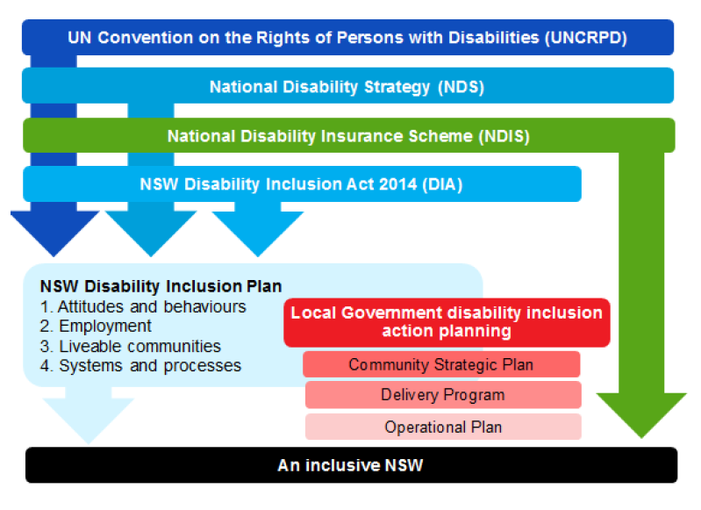
Image source: Local Government NSW and NSW Family and Community Service - Disability Inclusion Action Plan guidelines

NSW Disability Inclusion Act 2014
The NSW Disability Inclusion Act 2014 includes a series of principles which relate to people with disability and recognise the needs of particular groups. S.12 (3) of the NSW Disability Inclusion Act 2014 requires each public authority to prepare a Disability Action Plan. Section 12 (3) requires councils to prepare a Disability Inclusion Action plan which must include:
- how the Council regards disability principles;
- strategies for providing access to public buildings, events and facilities;
- details about how to access information;
- how employment opportunities for people with a disability are to be supported;
- demonstrate opportunities for people with disability to access the full range of services and activities available in the community, and
- include details of consultation about the plan with people with disability, and
- explain how the plan supports the goals of the State Disability Inclusion Plan.
As a result, this plan sets out a series of principles, strategies and actions that will guide Council operations over the next four years. These align with the principles of the Disability Inclusion Act 2014, as well as the NSW Government's Disability Inclusion Plan which specifies four focus areas.
The four focus areas "are aimed at creating long term change and require consistent efforts from government and the wider community".
These are:
- Developing positive community attitudes and behaviours
- Creating liveable communities
- Supporting access to meaningful employment
- Improving access to mainstream services through better systems
and processes

NEWCASTLE CITY COUNCIL
DISABILITY ACCESS AND INCLUSION ACTION PLAN
From the legislative framework, Newcastle City Council has developed its overarching Statement of Commitment which is included at the front of the plan. At the back of the plan under each focus area is a guiding principle and a series of strategies and actions which are the vital component to strengthening Newcastle as an accessible and inclusive city.
Having a separate plan is consistent with Newcastle City Council's strategic planning framework in which Council undertakes a series of core strategy documents (such as the Local Planning Strategy, the Social Strategy and Transport Strategy). From these core strategy documents, a series of action plans and masterplans (such as the Cultural Plan, Multicultural Plan) are prepared to give more detail and structure to important aspects within our community and for Newcastle City Council. The Disability Inclusion Action Plan is within this suite.
These plans are a particularly important component of Newcastle City Council's strategic planning framework and map out the Council's intentions for the next
four years.
Newcastle City Council has elected to prepare its Disability Inclusion Action Plan in advance of the 4 year Delivery Plan due in 2017 which forms part of the integrated planning and reporting process required under the Local Government Act 1993.
The Disability Inclusion Action Plan will be used to inform the development of future delivery plans.
Disability Inclusion Action Plan 2016 – 2019 13

The diagram below shows how the Disability Inclusion Action Plan fits into the integrated planning and reporting framework of local government.
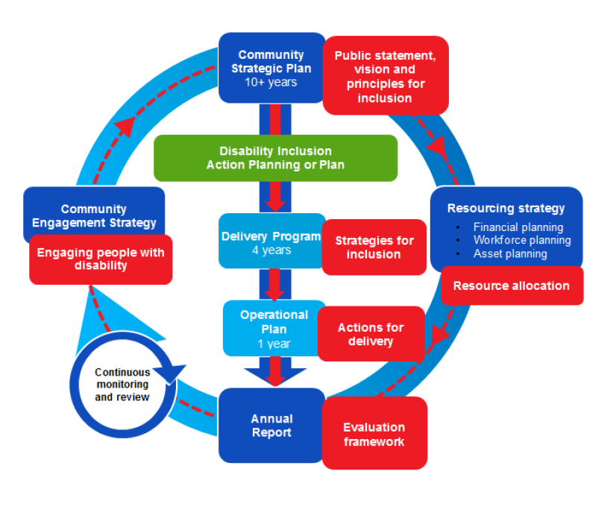
Image source: Local Government NSW and NSW Family and Community Service - Disability Inclusion Action Plan guidelines

COUNCIL'S ROLE IN WORKING
FOR THE COMMUNITY
For Council, Community Development is active engagement with individuals, organisations and communities to enhance a sense of belonging and the capacity
to make decisions and act together on our common priorities using our strengths as
a foundation.
Council works closely with State and Federal Governments, as well as other community based organisations, to ensure our resources are targeted to add value to each agency's programs and projects.
State and Federal governments are responsible for ensuring people have access to services such as health, education, police, housing, communications, emergency management and other social services to support and improve quality of life. In NSW, this is outlined in the NSW Premier's Priorities (September 2015).
Newcastle has a broad range of non-government organisations (charitable or not for profit) addressing a diversity of social needs in areas such as youth, disability, access to food, training, aged care, mental health and emergency accommodation.
Council has a range of roles in delivering outcomes for community planning and development which include:

Provider of Facilities or Programs
We will provide a range of facilities and programs that meet the social, cultural and recreational needs of the community.

Leader
We will identify key community issues and mobilise both local and external stakeholders to respond where appropriate. This leadership can be in the form of advocacy, facilitation or negotiation.

Collaborator
We don't compete with other community organisations for funding. However, we can partner with community organisations and other levels of government in projects to deliver tangible benefits to the community.

Planner
We will use our professional expertise to undertake research, provide information, and in consultation with community stakeholder, develop and evaluate ways to resolve identified issues. We will undertake this work from a whole of community perspective.

Capacity Builder
We will work closely with community groups and agencies to meet local needs. We will mentor and/ or assist community groups to obtain the necessary resources through partnerships with other agencies.

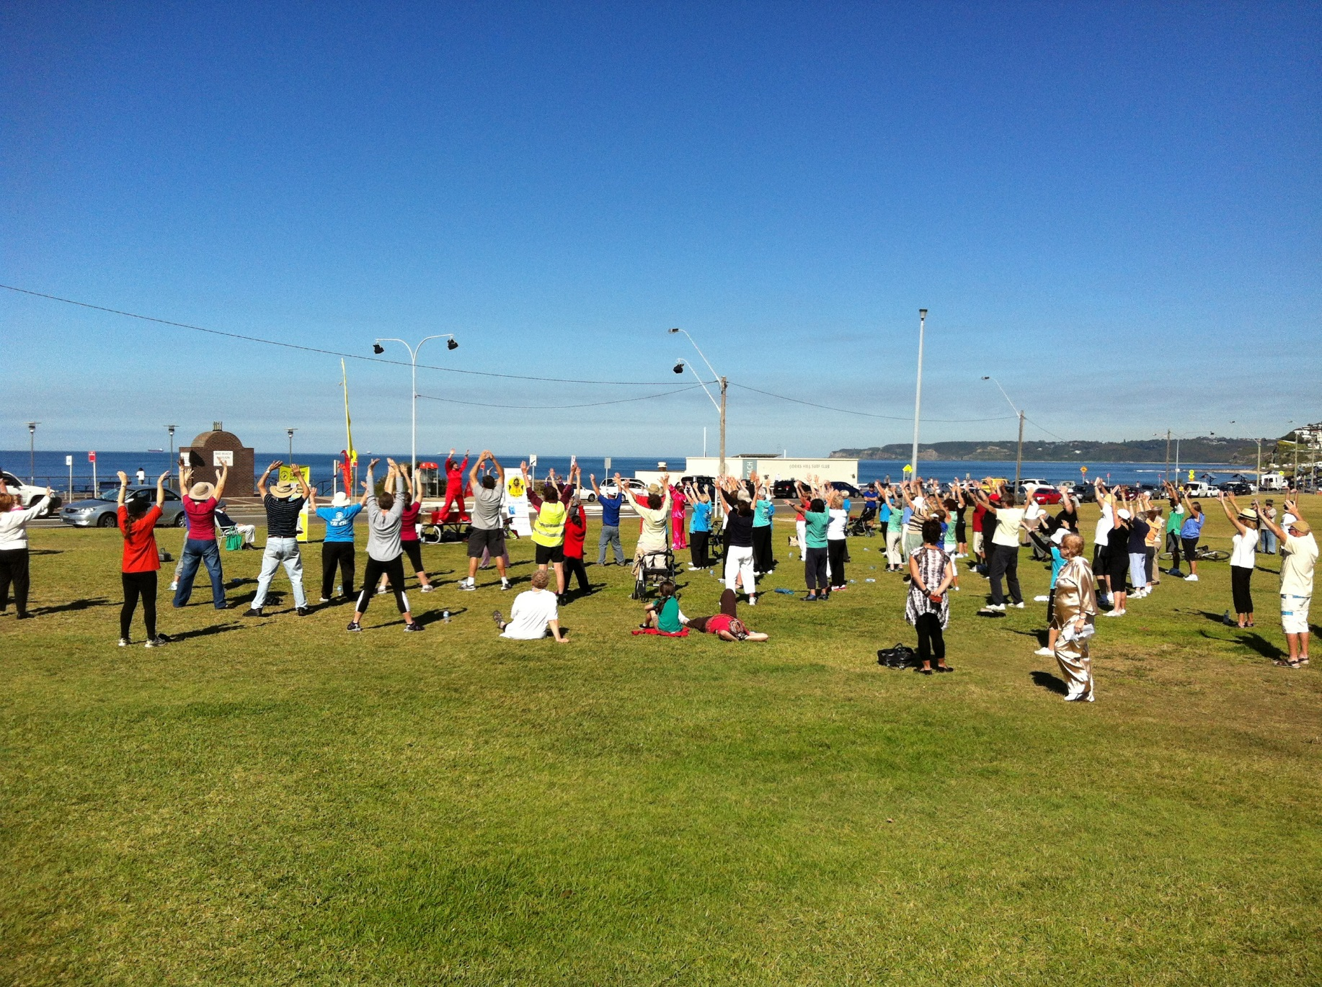
16 Newcastle City Council

COUNCIL'S COMMUNITY PLANNING AND DEVELOPMENT ROLES AND RESPONSIBILITIES
- planning for and upgrading facilities and centres for a growing, ageing and diversifying resident population
- planning and leading for changes in technology and employment
- maintaining 124 sports fields, 9 community centres, 4 seniors centres and 7 community halls
- providing grants for programs in the community
- collaborating to keep the community safe, healthy and resilient
- building capacity within the community to keep people socially connected and able to get out and about
- providing leadership and giving people the opportunity to participate in community consultations
- responding to in excess of 480,000 customer enquiries annually
- facilitating community events and festivals
- operating programmed venues such as Newcastle Libraries, Newcastle Museum and Newcastle Gallery
- caring for the foreshore, coastal areas and pools including 27km of beaches and foreshore, 2 ocean baths
Disability Inclusion Action Plan 2016 – 2019 17

COMMUNITY CONSULTATION AND EMERGING KEY ISSUES
IN NEWCASTLE

Prior to Draft Being Prepared for Exhibition:
- 3 'Straight Talking' Workshops (two for community members and a workshop held in partnership with Disability Network Hunter for the disability sector) attended by a total of 38 participants.
- Meetings with relevant managers and staff from NCC Business Units.

Documentation Available
- Draft document available in accessible PDF, Easy Read and text only.

Newspaper Advertisements
- Newcastle Herald Saturday 23/01/2016
- Newcastle Herald Wednesday 03/02/2016
- Newcastle and Lake Macquarie Star Wednesday 10/02/2016

Daily Radio Adverts
- Radio 2RPH - 3 daily plays of a 30 second promo played during
Newcastle Herald broadcasts (12/02 - 18/02)

Online & Social Media
- Exhibition Details on between 25/01/2016 and 24/02/2016
- Links to exhibition from Newcastle Regional Library Homepage
- Share on Facebook from Newcastle City Council and numerous community Facebook pages.

Email Marketing
- Distribution of information through various network databases reaching over 300 individuals from community and disability sector.

Workshops and Library Drop in Information Sessions
- 2 workshops on draft plan - City Hall and Wallsend Library attended by a total of 13 participants.
- 9 'Drop in' Information sessions at branch libraries across the LGA
- Individual and group meetings on request.
In preparing this plan, consultations with external community stakeholders were held during development in November-December 2015 and again throughout the exhibition period in February 2016 (workshops, drop-in sessions, various media) across a range of venues.
A number of key themes were consistently identified throughout all of the consultations. The opportunity to constructively engage with Council was highlighted with many robust discussions contributing to Council's understanding of the challenges that people with a disability experience across the Newcastle.

THE KEY MESSAGES FROM THE CONSULTATIONS AND FEEDBACK IS SUMMARISED AS FOLLOWS:

Awareness and Recognition
Community stakeholders repeatedly asked that they be not singled out as a 'person with a disability', but rather be recognised for the contributions that they made to their community across all areas of society, be treated with respect and dignity and have the opportunity to participate fully in Newcastle community life. It was communicated that disability is diverse, can be hidden and that any stereotyping, assumptions or generalisations needs to be removed from the rhetoric. Stakeholders clearly stated individuality, equity and the right of choice as being central to the ongoing dialogue at a community level and beyond.
Stakeholders commented that there was opportunity to understand more about disability in the Newcastle community, meaning that there was a need to get a clearer picture of the disability community and the contribution that individuals and groups made to Newcastle. This should be celebrated and promoted.
It was noted that many people with a disability were frequently financially disadvantaged due to reduced access to employment opportunities. Following on from this, it was articulated that some members of the disability community experience a greater level of disadvantage to others due to their life circumstances and this can limit capacity to participate in community and civic processes.
Similarly, it was reported that some members of the community do not have the experience to participate in consultative processes and this should always be taken into consideration.
Stakeholders noted that Council needs to continually outreach to members of the disability community, acknowledging that diverse methods of communication and participation need to be used to enable more individual, groups and communities to be involved.

Public Domain Improvements
Stakeholders highlighted the importance of the public domain in enabling them to participate in an inclusive society. The public domain includes footpaths, kerb ramps and wayfinding to broad precincts such as such as beaches, ocean baths, parks, shopping strips and transport infrastructure. Community members reported the need for Council to better communicate and deliver on the design, upgrade and maintenance of both small and larger scale public domain improvements. Design faults and ageing infrastructure can result in a visually impaired person finding themselves in the middle of an intersection or a wheelchair user unable to get onto the footpath on the opposite side of the road.
Discussions strongly communicated the need to participate and inform Council of opportunities to improve the public domain, particularly when access challenges are identified; how to make information accessible in the in the planning and design stages of new works; developing a better understanding of how works are prioritised and scheduled annually and how to participate in determining what upgrade works occur where. The issue of the relevant Australian Standards for design and also Building Code of Australia (BCA) (now known as the National Construction Code) were frequently raised by stakeholders who stated that these standards were perceived as a low benchmark (the minimum requirements) and that in designing public buildings and spaces, capital works should deliver at a higher accessibility standard to enable genuine inclusion.

Accessible Public Toilets
Public toilets are critical enabling infrastructure for all of our community as they engage in their activities of daily living, from work, travel, shopping, cultural and recreational pursuits. Without accessible toilets, inclusive community participation and wellbeing is significantly constrained, if not almost impossible.
Stakeholders regularly raised the lack of accessible toilets generally, the sometimes poor condition and maintenance of accessible toilets across the LGA. The design of these spaces was considered important as the placement of rails, lighting, hand basins, hand drying, shelves (a clean place to setup needed equipment) and whether a toilet was left or right 'hand' was critical.
A significant issue raised was the MLAK key system which was seen as achieving significant outcomes when the scheme was first initiated however the need to purchase a special key is perceived by some users as discriminatory and exclusive. Wayfinding (signage and paths of travel) to accessible toilets across the LGA was also an area that could be improved.

Accessible Parking
For people with disability and their carers, the availability of accessible parking infrastructure was a critical part of access to activities of daily living. The provision of information about the location of accessible parking was an area stakeholders identified that could be improved.
This included information that would support journey planning and it was recommended that information be shared in accessible formats across a variety of channels.
It should be regularly updated and could include accessible toilet locations also. Regulatory management of accessible parking spaces and permit systems would that would enable use of the spaces was highlighted as an important role of Council. With reference to parking, the ability of the community to participate in planning and delivery processes, Council responsiveness to complaints and a number of innovative solutions were proposed to enable further engagement.

Community and Council Events
Community stakeholders identified a range of positive aspects to living in Newcastle. These included the relaxed atmosphere and lifestyle, the local connections, the beaches and activities such as bands, theatre, the fabulous and rich arts scene, festivals and markets.
Stakeholders identified accessibility to and around events and venues as a major challenge to participation and inclusion. Improvements in access to community and flagship events, and how events are licensed, were extensively raised throughout the consultation.
Council was seen as being a community leader in this area and where events were either run by Council, or where financial or in-kind support was provided, event accessibility should be promoted. Stakeholders highlighted that access as a concept not only meant entry and egress but also included parking or transport alternatives, toilets and inclusionary participation at the event itself.

Access and Inclusion Advisory Committee
Within the consultations, both individuals and community organisations raised the importance of a strategic advisory committee and ideas about the function of such a committee. Ideas suggested a committee would provide a strategic advice to Council on access and inclusion matters broadly and oversight of the implementation of the Access and Inclusion Plan. The formation of an advisory committee was generally seen as a critical contribution to an ongoing dialogue between Council and the community in advocating for equal rights and an inclusive Newcastle. It was however only one mechanism that should be employed. Council staff communicated that a committee could only be formed in the next term of Council and that was influenced by a number of factors beyond the scope of the plan.

Communication and Engagement
Council's communication and engagement practises were raised as being a critical factor to breaking down barriers to access and inclusion for the community. The message received was that 'if Council wants people with disability to be engaged citizens of the community information, then participation channels need to be improved'. Some recommendations included:
- the importance of Council's website and documents being accessible
- the need for Council to continue to offer diverse opportunities to engage members of the disability community, encourage participation and provision of feedback and for Council to lead the process with alternative formats
- consult the disability community and/ or access specialists early in the design process as access should be a guiding principle, rather than an afterthought.
- make information accessible, particularly about key infrastructure projects such as footpaths, toilets and kerb ramps and for programs such as events and partnerships
- the importance of a respectful organisational culture for all people who require increased accessibility to be able to participate in their community with dignity

Advocacy and Collaboration
Council was seen as having a significant role as a community leader in both advocating for and delivering improved accessibility within our facilities and programs for the Newcastle community. As a community leader, Council could help to set the agenda for access and inclusion through our capacity to network, consult and collaborate across all aspects of the community and government sectors and deliver outcomes for the whole community. Numerous potential partnerships were suggested for consideration.

Matters of Increasing Concern within the Community
In the spirit of an open and engaging consultation, stakeholders put forward information and lived experiences with regard to inclusion in the community, access to public transport, appropriate and affordable housing and access to meaningful employment opportunities. Factors widely acknowledged as being linked to health and wellbeing. In Council's role as a leader, advocate and collaborator, this information was recorded to help inform and guide not only the implementation of this plan, but other projects and developments within Newcastle.

Moving Forward
Overall, the stakeholder input has assisted Newcastle City Council in developing and refining the strategies and actions included under each outcome area -
Attitudes and Behaviours, Liveable Communities, Employment and Systems and Processes.
In the spirit of consultation, dialogue with the community has enabled reflection and refinement of the strategies and actions that will be implemented over the next four years.
This represents a summary of key issues and concerns raised in the community consultation process. It is considered to be the beginning conversation with the community as we look to implement Newcastle City Council's first Disability Inclusion Action Plan under prepared under s.12 of the Disability Act 2014.
Specific strategies and actions are included within this plan that will build upon this initial consultation and diversify ongoing consultation and engagement with the community into the future.
Under the guidance set by the NSW Disability Inclusion Act, this process can be looked upon as a new journey - for Council, its agency partners, business and most importantly the community - towards Newcastle becoming an accessible and inclusive society for all.
Disability Inclusion Action Plan 2016 – 2019 23

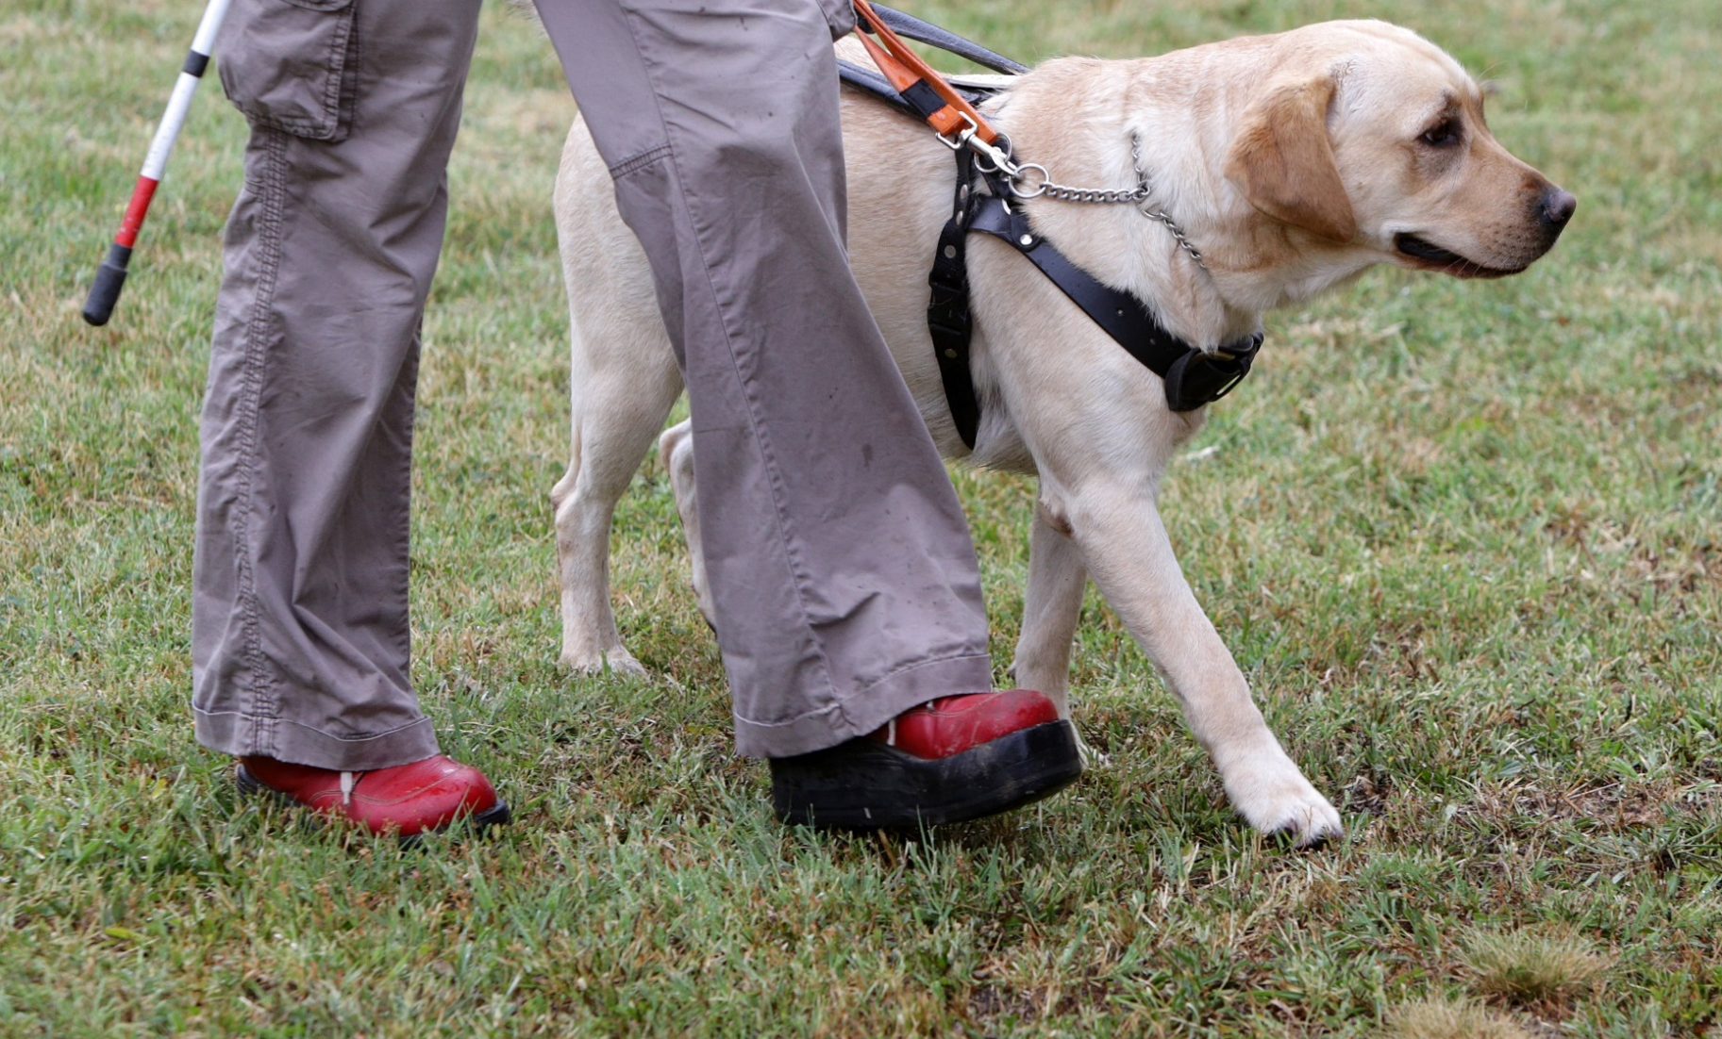
Disability Inclusion Action Plan 2016 – 2019 23

STRATEGIES AND ACTIONS

FOCUS AREAS:
- ATTITUDES AND BEHAVIOURS
- LIVEABLE COMMUNITIES
- EMPLOYMENT
- SYSTEMS AND PROCESSES

OUTCOME AREA: ATTITUDES AND BEHAVIOURS
Council encourages positive and inclusive staff behaviours, and a whole of community attitude, to people with a disability. We champion behaviour that respects and embraces diversity and difference within the disability community.
STRATEGY | ACTION | OUTCOME | DELIVERY
- Demonstrate leadership in public programming | - Commence building and programming audits to enable increased access to public programming | - Audits commenced | Ongoing
- Demonstrate leadership in public domain developments | - Establish a process for structured community consultation on identified public domain improvement projects | - Process developed and implemented | 2016
- Improve staff awareness of disability issues in the community in order to provide responsive services for customers with a disability | - Develop and implement frontline staff procedures to improve service delivery and complaints handling for people with a disability  - Provide targeted disability awareness training for current and future call centre and frontline customer service staff  - Include disability awareness training in staff induction  - Undertake ‘break down the barriers’ awareness with councillors, executive leaders and staff | - Operating procedure developed  - Training developed and delivered  - Module included  - Two sessions per year facilitated | 2016  Ongoing

- Establish partnerships which address community wide barriers to access and inclusion | - Participate in community programs addressing whole of community barriers (such as transport forums)  - Collaborate with NSW Government agencies  (eg Transport for NSW, Urban Growth) to improve access and inclusion within the Newcastle local government area  - Continue to work with key community organisations and advocacy groups  - Establish a community advisory committee in the next term of Council | - Projects per year | Ongoing
- Celebrate inclusive practice and access outcomes | - Promote Council projects that improve access to Council services and in public places, through Novonews, Council newsletters, Council's website and in external publications where possible | - Promotions occur when available | Ongoing

OUTCOME AREA: LIVEABLE COMMUNITIES
Council contributes to and advocates for a liveable and welcoming Newcastle,
where community places, neighbourhoods and facilities promote health, happiness and wellbeing and contribute to social connectedness. This includes important liveability factors such as housing design, transport access, community recreation and social inclusiveness.
STRATEGY | ACTION | OUTCOME | DELIVERY
- Contribute towards liveable and accessible public places | - Implement a strategic approach to include community input at concept design stage on identified projects in public places.  - Identify priority locations to undertake pedestrian access and mobility plans to inform accessible paths of travel between major facilities and services  - Undertake an LGA wide assessment of community infrastructure to identify location, design, delivery and management of accessible toilet and change facilities  - Advocate for access and inclusion to be a guiding principle in the development of plans of management prepared under the Local Government Act, relevant public domain masterplans and the emerging Newcastle Intergenerational Playground Strategy  - Facilitate specialist training for identified technical staff for access auditing and compliance with relevant codes and standards  - Identify and promote accessible council venues and infrastructure | - Procedure developed and implemented on agreed projects  - Locations identified annually  - Assessment completed  - Emerging policy frameworks identified | 2016 &  Ongoing  2017  Ongoing

- Continuously upgrade council assets to meet the requirements of the Disability Discrimination Act, relevant Australian Standards and the National Construction Code | - Identify and prioritise public buildings that require access audits in accordance with AS1428.1 - Access to Premises standards  - Ensure access criteria are included in community service levels that enable the sustainable management of fit for purpose community facilities and assets  - Review the Pedestrian Access and Mobility Plan (2001) to ensure all new road and transport infrastructure works (pedestrian crossing, bus shelters) undertaken by Council are coordinated and in accordance with current legislation. | - Priority buildings identified and audits completed  - Opportunities to provide input identified  - Plan review completed | 2016  Ongoing  2017
- Advocate for improved access and inclusion outcomes in 'whole of government' policy settings | - Advocate for access and inclusion to be a guiding principle for Newcastle City Centre urban renewal project  - Work with Urban Growth to ensure improved outcomes for people with a disability within Newcastle City Centre  - Continue to advocate for delivery of accessible and affordable housing the Newcastle local government area  - Continue to advocate for universal housing design in the delivery of new housing stock  - Collaborate with Transport for NSW for improved transport equity within the Newcastle local government area  - Implement the relevant actions adopted in the Newcastle Transport Strategy  - Work with community transport providers to maintain understanding of issues impacting the disability sector  - Provide input to the Newcastle Local Traffic Committee to improve access outcomes | - Opportunities to participate identified | Ongoing

- Contribute towards programs which aim to increase social inclusion and community connections | - Advocate for accessible and inclusive whole of community events facilitated by Council  - Promote the benefits of accessible business practice through the Business Industry Associations  - Participate in partnerships projects which aim to increase social inclusion in Newcastle  - Develop a resource promoting local inclusive sporting, recreation and cultural programs included within the Newcastle local government area | - Programs and projects identified annually | Ongoing

OUTCOME AREA: EMPLOYMENT
Council maintains its commitment to equal employment and workplace opportunities and the ongoing commitment to reducing barriers for current and future employees to remain and thrive in the workplace.
STRATEGY | ACTION | OUTCOME | DELIVERY
- Develop Council employment opportunities for people with a disability | - Audit human resource policies, procedures and practices to ensure compliance with current legislation  - Develop a training module with current recruitment and selection training identifying Council's Equal Employment Management Plan and workplace support available to employees with a disability  - Examine potential for targeted recruitment initiatives within the development and implementation of the Workforce Management Plan 2017-2021 | - Policies reviewed and training packages implemented | Ongoing  2017
- Improve organisational capacity to support a diverse workforce | - Undertake engagement with staff who identify as having a disability or primary caring responsibility to better understand and meet their needs  - Promote workplace flexibility options available under the Newcastle Enterprise Agreement to staff who have primary caring responsibilities | - Voluntary staff survey conducted  - Fact sheet developed and promoted | Ongoing
- Provide volunteering opportunities for people with all abilities | - Review volunteering policy to ensure Council volunteering opportunities are accessible and inclusive | - Policy reviewed | 2017
- Identify opportunities to procure goods and services from local business who employ people with a disability | - Develop a list of Newcastle LGA based business who provide meaningful employment to people with a disability  - Review procurement policy and procedure to identify options to procure goods and services from identified businesses | - List developed and promoted  - Procedure reviewed | 2016

OUTCOME AREA: SYSTEMS AND PROCESSES
Council continues to improve its capacity to assist our community to gain access to the information and council services they need to realise their full potential .We encourage the community to actively participate and partner with Council for improved decision making and service delivery.
STRATEGY | ACTION | OUTCOME | DELIVERY
- Ensure accessible and inclusive community engagement | - Audit community engagement policy and processes to deliver improved access and participation in Council community consultations  - Prepare guidelines promoting continuous improvement principles for staff engaging people with a disability in projects and programs  - Identify Council publications and communications that are to be made available in multiple formats annually | - Audit completed guidelines produced.  - Publications per annum | 2016  Ongoing
- Promote a culture of responsive customer service | - Produce guidelines on respectful and effective communication  - Review Council customer service process to identify barriers to access and communication for community members  - Review customer feedback and complaint management systems to ensure accessibility and equity for people with a disability  - Include accessibility as an indicator on customer satisfaction surveys  - Provide information on National Relay Service to customer service teams | - Review completed and projects identified and delivered | 2017

- Continuously improve regulatory processes within the organisation to achieve outcomes for the disability community | - Develop and promote a publication explaining Council's planning and management of accessible on street parking  - Monitor compliance with Council's footpath dining licences  - Provide input on matters of access where relevant to amendments of the Newcastle Development Control Plan  - Provide advice where appropriate on access and inclusion in the development assessment process  - Advocate for s.94 (development contributions) funding to be directed to projects which improve access in public places | - Projects completed annually | Ongoing
- Champion inclusive events and community programs | - Update Council's event management process and procedures to include access and inclusion criteria and information  - Amend the Major Event Sponsorship agreement to include an accessible event plan  - Promote Council's community funding programs within the disability sector and community | - Review completed and projects identified and delivered | 2016
- Promote and advocate access and inclusion considerations in project management, design and strategy development | - Audit project management processes to identify opportunities for access and inclusion considerations | - Opportunities to provide input identified | 2017

MONITORING AND EVALUATION
Each year, Council will report on its progress against the Disability Inclusion Action Plan as part of its Annual Report. A summary of achievements will also be prepared annually and provided to the NSW Disability Council.
32 Newcastle City Council

NSW Government Disability Inclusion Plan (2014)
United National Convention on the Rights of Persons with Disabilities (2006)
National Disability Strategy - NSW Implementation Plan 2012-2014
NSW Carers Strategy 2014-2019
United Nations (2006), Convention on the Rights of Persons with Disabilities
NSW Disability Inclusion Plan

